**Terminus codes:**

Ls LOCATION - to see items and locations

Cd LOCATION - to go to the location

Less ITEM -to use item

tellme combo – to get combination for a room in AthenaCluster

Cd .. - to go back

add Lockername - to add a locker in AthenaCluster which will be located at home. (MagicLocker is the first one)

Cd ~ OR cd - to go back home

mv OBJECT NEWLOCATION – to move object to a new location(only some objects)

help - gives a list of spells

man SPELL COMMAND – how to use a specific spell

rm ITEM/PERSON -to remove the item/person forever

mkdir – make a new place

grep PHRASE ITEM – to search for PHRASE in ITEM

cp ITEM NEWITEM – copy ITEM and name it as NEWITEM

touch ITEM – where ITEM is the name of the thing you want to create

sudo COMMAND – to run a command on a password-protected file. After typing this it will ask for the Password.

Ctrl + R – can search any previous commands



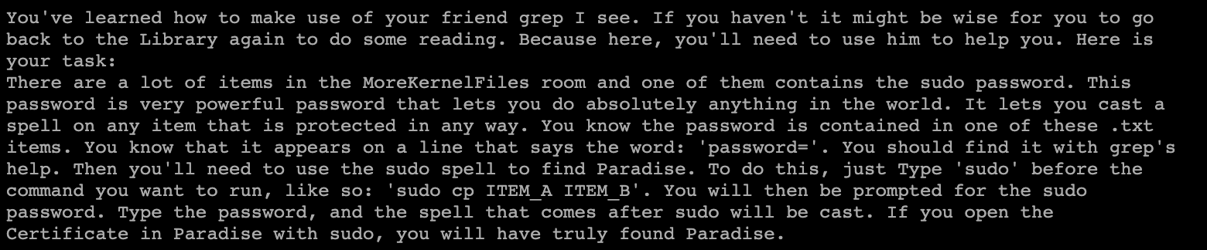

**Terminus MAP:**

digraph Terminus{

node[style=filled, color=yellow]

House[color=red]

Home -> WesternForest

Home->NorthernMeadow

Home->MIT

MIT->StrataCenter

MIT->AthenaCluster

WesternForest->SpellCastingAcademy

SpellCastingAcademy->PracticeRoom

PracticeRoom->Box

NorthernMeadow->EasternMountains

EasternMountains->Cave

Cave->{StairCase,DarkCorridor}

DarkCorridor->DankRoom

DankRoom->{SmallHole,Tunnel}

Tunnel->StoneChamber

StoneChamber->Portal

Portal->TownSquare

TownSquare->{MarketPlace,Library,RockyPath,ArtisanShop,BrokenBridge}

Library->BackRoom

RockyPath->Farm

BrokenBridge->Clearing

Clearing->{OminousLookingPath,House}

OminousLookingPath->{Cage,Slide}

Slide->KernelFiles

KernelFiles->{MoreKernelFiles,Paradise}

}

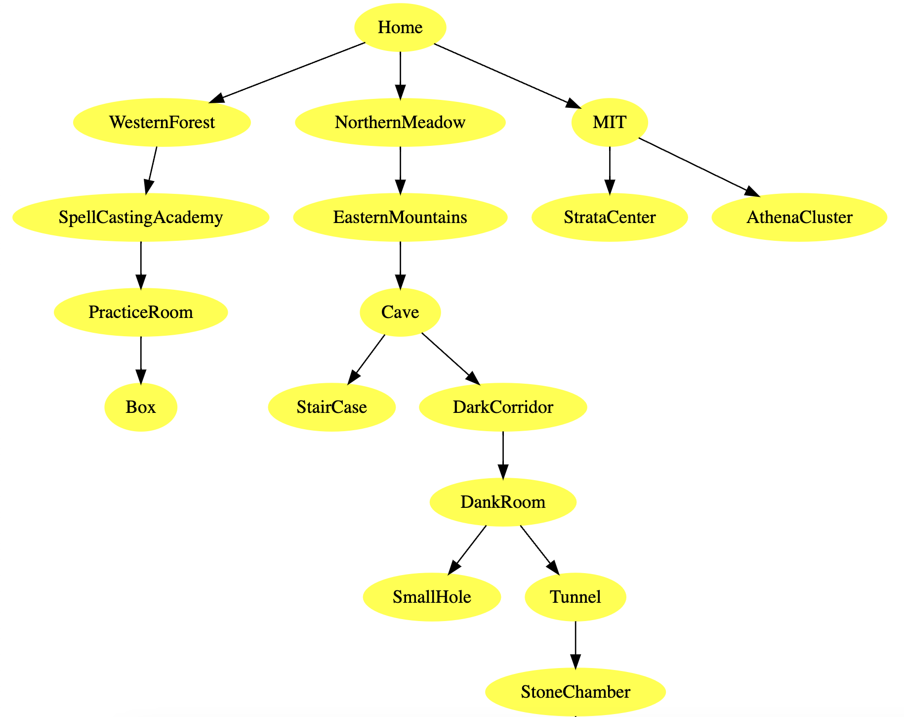

FINAL MAP:

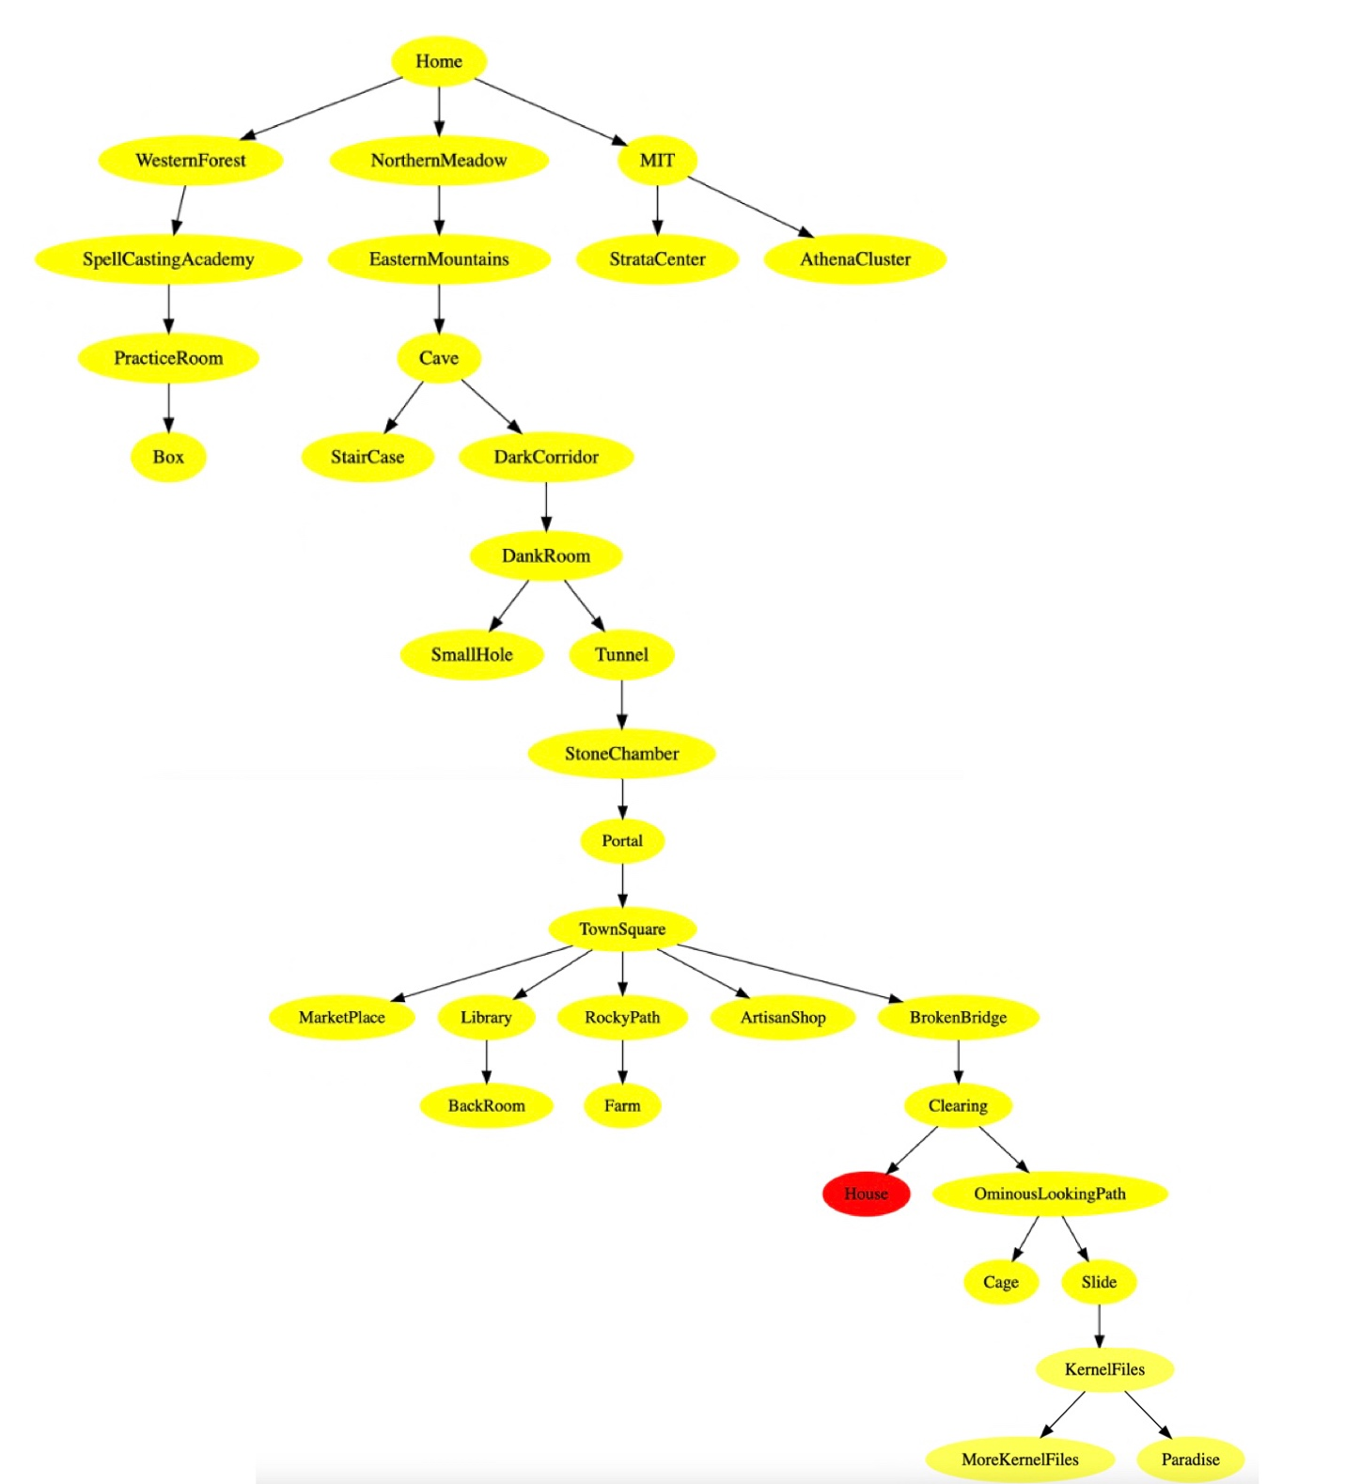

Western Forest: sign and backsign

OldManuscripts (not counted)

Dead end sign (at staircase)

Total: 3 signboards.

In Linux, source code is freely available and can be modified and distributed by anyone. Additionally, Linux is often more customizable. Until now for MAC I have been interacting through GUI but for Linux, we have been giving commands through bash in the terminal. So, it seems that for Linux the commands are more efficient. But I feel that Windows and MAC OS are more user-friendly and have better-looking GUI.